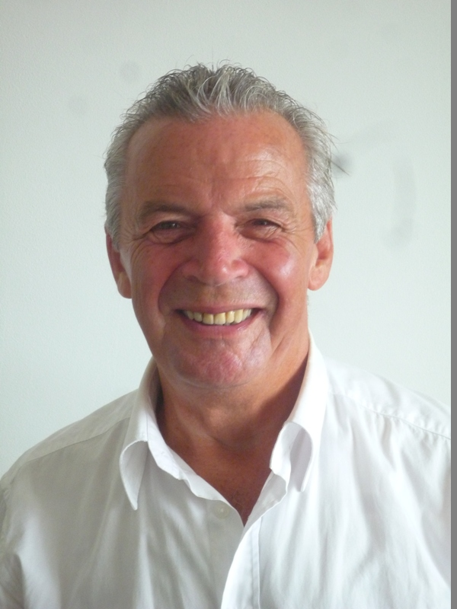

Curriculum vitae

Name: Carlos Emilio Larrosa Lombardi
Adress: Rua 5 – quadra G – lote 13 – Joao Fernandes
CEP: 28.950.000 –Buzios – RJ – Brazil.
Tel.: 022 – 26232259 * cell: 022 – 99907-5047
Nationality: Uruguayan
Father: Francisco Larrosa
Mother: Elida Lombardi
Identity Number: YOO9873-V – RNE
Driver License No: 01137355289

Studies

High School – Liceo Hector Miranda – Montevideo, Uruguay.
Administration Course – Universidad del Trabajo,
English Course – Universidad del Trabajo, Montevideo.
English Proficiency Course at United Nations, Vienna
Subtitles and captions – DeLuxe Media

Working Experience Clerical job at Hobbins & Co. Import and Export – Montevideo
Spanish and Portuguese teacher at Berlitz School of Languages – Vienna.
Translator/interpreter at the United Nations Industrial Development Organization – Vienna.
Freelance translator for UNIDO, IPEA and translation agencies.
Translation/edition for Wagner Consulting LLC.

English teacher for intensive courses at Language Planet, Macae.
Freelance translations and proofreading for several websites (England and Sweden)
Translation of user manuals,videos, films and books in Word and Trados. Translation of comic books for the Amazonian children.
Interpreter for the Brazilian Navy during the visit of the Bolivian Admiral.
Translations and subtitling of 40 video lessons for Pranic Healing, New York.

Languages
Spanish: Mother Tongue
Portuguese: Fluent
English: Fluent
German: Basic
French: Basic.

Buzios, 12/12/2017

